Date:

LO: To identify the main parts of the human body.

Science: Know the names of the main external body parts of humans and animals

Our body parts

Here are some parts of the body. Can you point to them on yourself?

|  |  |  |
| --- | --- | --- |
|  |  |  |
| elbow | arm | foot |
|  |  |  |
| hand | legs | finger |
|  |  |  |
| mouth | eyes | nose |
|  |  |  |
| ear | shoulder | knee |
|  |  |  |
| head | chest | toe |

Can you label the parts of the body?

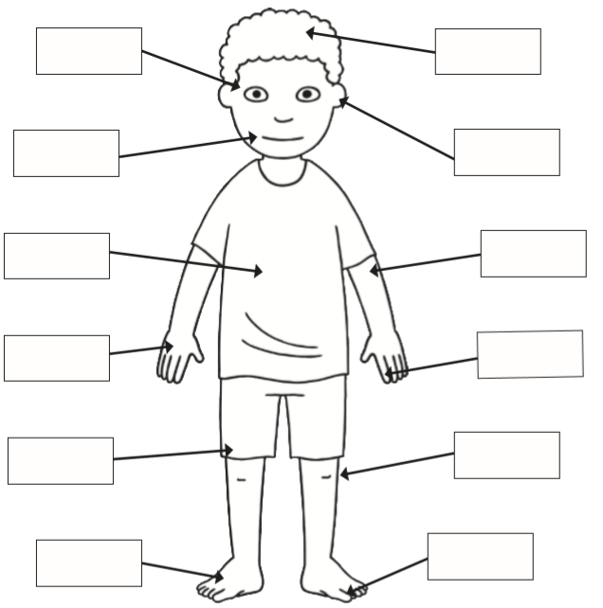

|  |  |  |  |  |  |
| --- | --- | --- | --- | --- | --- |
| foot | toe | hand | mouth | head | arm |
| leg | knee | finger | eyes | ear | chest |