Date: ____________________
LO: To be able to read scales in 2s, 5s and 10s.

1. Read the scales below and write how many grams each present weighs.
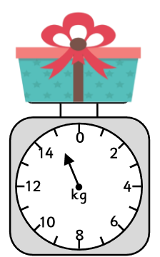
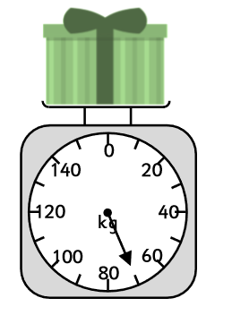

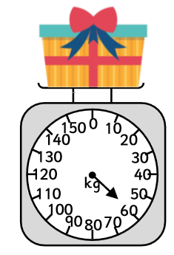
___________ ___________
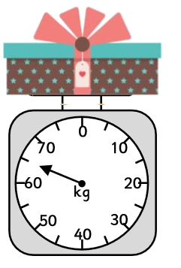

____________ ___________

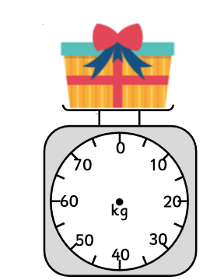
2. Draw the arrow on the scales to show the given weight.
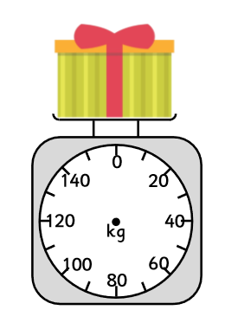
55g
50g

3. Joel says his item weighs 25g, is he correct?
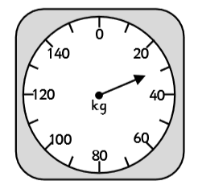
Explain your reasoning.
________________________________________________________________________________________________________________________________________

4. Use < or > to complete the statements.
Banana Apple
15g 12g

Toy car Teddy Doll
8g 18g 40g

