WB 1st June
Spelling homework: copy each word five times. Challenge: write one sentence using one of the words
Spelling rule: ‘sion’ & ‘tion’
Day 1 | Day 2 | Day 3 | Day 4 | Day 5
action | potion | vision | occasion | pension
lotion | ration | decision | conclusion | extension
motion | caption | division | invasion | tension
nation | caution | television | confusion | expansion
option | emotion | version | explosion | question

Use your green exercise books to complete this work.
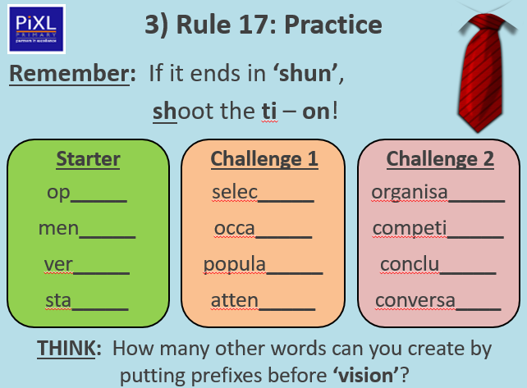
Ask someone at home to read out the dictation for you to write without looking at it.
