Date: ______________________________________________________
LO: To recall and use division facts for the 10 times table.

Varied Fluency

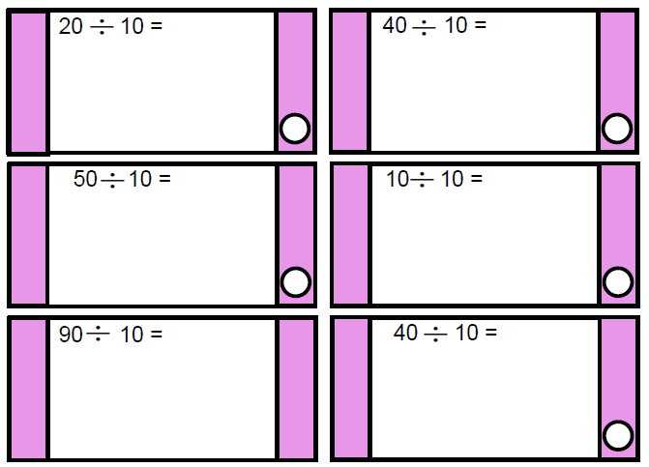

Reasoning and Problem Solving

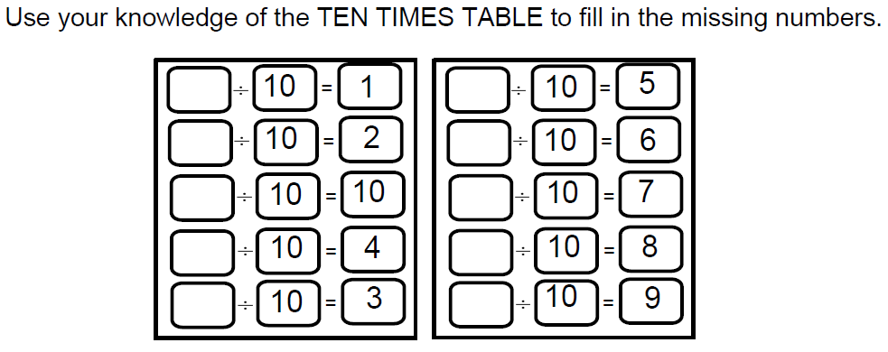

LO: To write simple fractions.

Varied Fluency

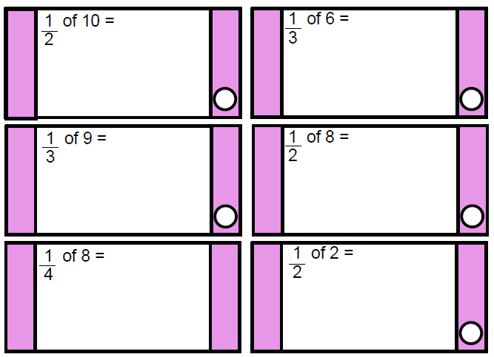

Reasoning and Problem Solving

