What is fossilisation? A look at how fossils are formed. 29.6.2020
Palaeontologists study fossils of creatures that lived millions of years ago to help us understand our world better.
When an animal dies and ends up in the sea or near water, it will eventually be covered by layers of rocks and sand. Over time, more layers of rock cover it and by this time the only thing that remains of the animal is probably the bones.
Over thousands of years, the mould fossil might become a cast fossil with sediments entering the mould. Over a long period of time, the sea will recede (push back) in some places exposing rocks and sand. As erosion and weathering takes place, eventually the fossils become exposed and people can dig them up and study them.

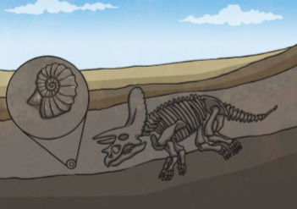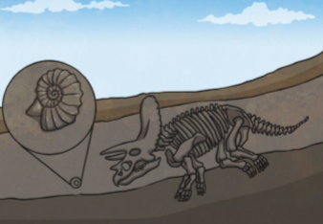

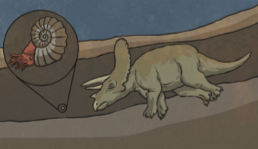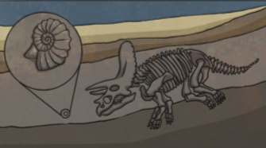

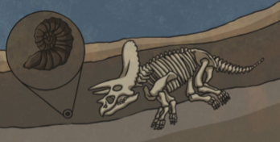

LO: to explain the process of fossilisation 22.6.2020
SC: 1. Read the notes carefully for understanding
2. Use the pictures to help you understand
3. Cut out the pictures and create a table to show how fossils are formed
4. Write out captions for each picture and number them carefully.

