Fiction Writing: To write your own fairy-tale
This week we would like you to write your own fairy-tale!
We will start by thinking of a suitable setting and main character, then plan out your story, write it and finally edit it.
Please remember when writing a fairy-tale you need to ensure you stick using settings and characters that you would find in a fairy-tale – no modern-day items!
If you find this tough, take a fairy-tale that you know and change a few elements.

Remember to use the following things in all of your writing:
. Capital letters
. Full stops
. Neat joined up handwriting
. Sound out your words carefully
. Spell common exception words correctly
. Use conjunctions: and/but/or because/when/if/that
. Use the correct tense

Don’t forget to read and edit your writing to make sure it makes sense!

Day 1
Where is your fairy-tale mainly set? Is it in a forest or in a castle? Who lives there?
* Draw a picture of your setting and label it with adjectives.
* Describe your setting in as much detail as you can. This will help you with planning your story.

________________________________________________________________

________________________________________________________________

________________________________________________________________

________________________________________________________________

________________________________________________________________

________________________________________________________________

________________________________________________________________

________________________________________________________________

________________________________________________________________

________________________________________________________________

________________________________________________________________

________________________________________________________________

Day 2
Who are the main characters in your story?
In a fairy-tale there is usually a problem that needs overcoming. Are both your characters good? Is one good and one bad? When you are deciding on your characters, think about what conflict might happen in the story.

* Choose two characters to draw and describe.
* Describe your characters in full sentences and use conjunctions.

________________________________________________________________

________________________________________________________________

________________________________________________________________

________________________________________________________________

________________________________________________________________

________________________________________________________________

________________________________________________________________

________________________________________________________________

Day 3
What happens in the story? In the beginning you will need to describe the setting and place the characters in the setting. In the middle there will be a problem that the main character needs to overcome. The ending will be the resolution to the problem. Don’t forget, the main character needs to live happily ever after!
* Try to break the story down into a beginning, middle and end.
* Draw a picture for each part and tell us what happens.

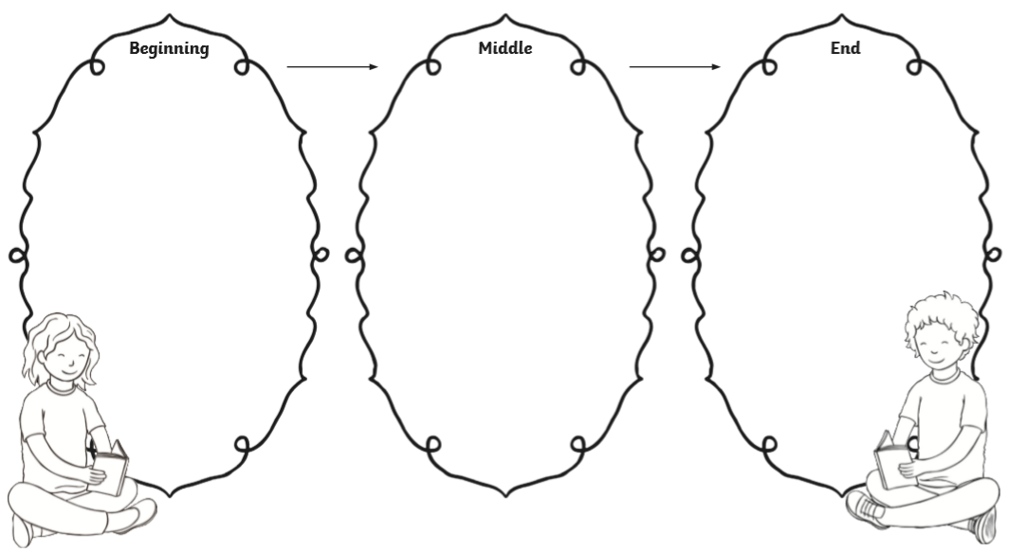

Day 4
Write out your story?
Remember to make sure your story makes sense and don’t rush through it! Explain exactly what happens in every stage of your story. When you are finished, go back and edit it with a pen in a different colour.

________________________________________________________________

________________________________________________________________

________________________________________________________________

________________________________________________________________

________________________________________________________________

________________________________________________________________

________________________________________________________________

________________________________________________________________

________________________________________________________________

________________________________________________________________

________________________________________________________________

________________________________________________________________

________________________________________________________________

________________________________________________________________

________________________________________________________________

________________________________________________________________

________________________________________________________________

________________________________________________________________

________________________________________________________________

________________________________________________________________

________________________________________________________________

________________________________________________________________

________________________________________________________________

________________________________________________________________

________________________________________________________________

________________________________________________________________

________________________________________________________________

________________________________________________________________

________________________________________________________________

________________________________________________________________

________________________________________________________________

________________________________________________________________

________________________________________________________________

________________________________________________________________

________________________________________________________________

________________________________________________________________

________________________________________________________________

________________________________________________________________

Day 5
Design the front cover of your fairy-tale.
* Make sure you include a title at the top and the author (you!) at the bottom.

____________________________________________

_____________________________________________________________

