Date: ________________ LO: To identify and record the properties of 2D shapes

Varied Fluency
2D Shape | Name | Number of Faces | Number of Edges | Number of Vertices

Problem solving:

- What is the same about a square and a rectangle?
_________________________________________________________________
_________________________________________________________________
- What is different about a square and a rectangle?
_________________________________________________________________
_________________________________________________________________
- Which 2D shapes have 2 sides?
_________________________________________________________________
_________________________________________________________________
- Which 2D shapes have 4 corners/vertices?
_________________________________________________________________
_________________________________________________________________
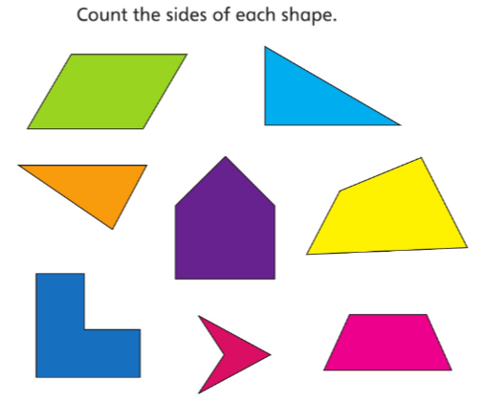
Jottings

