Maths Day 1 – Number Recap
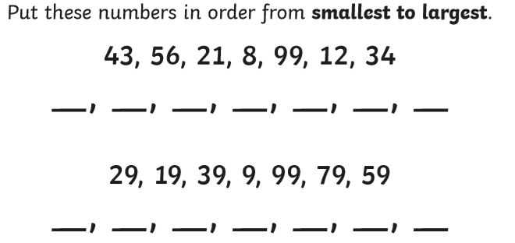

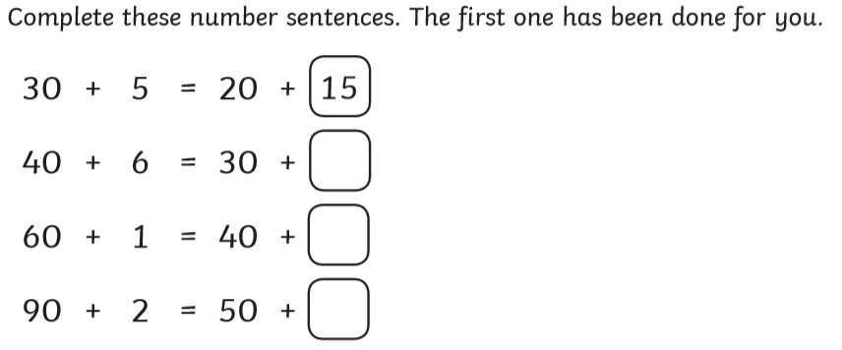

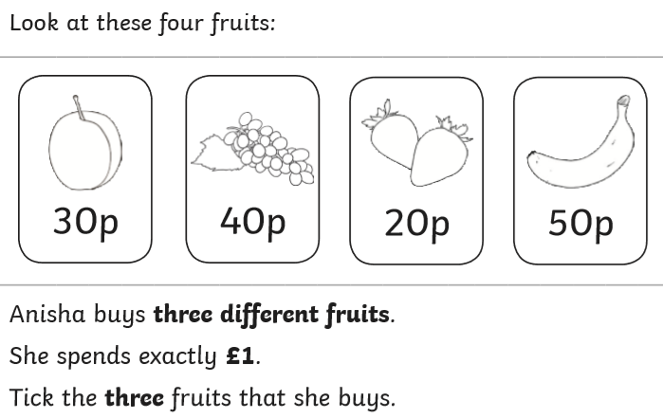

Maths Day 2 – Fractions Recap
Complete:
Half of 12 is ______
2/4 of 12 is ______
3/4 of 20 = _____
1/4 of 20 = ______

Shade 1/3 of each shape.
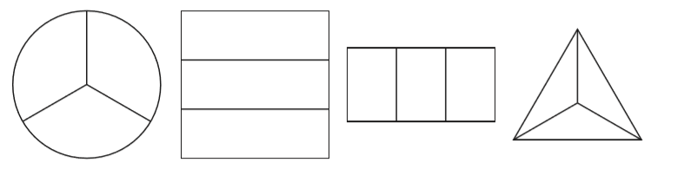

Word problems:
Jo bought a bag of 12 cherries. Jo ate half the number of cherries in the bag. How many cherries did Jo eat?
______________________

Sam bought a bag of 18 cherries. Sam ate 6 cherries. What fraction of the bag of cherries did Sam eat?
_____________________

If you count in steps of starting from 0, how many steps will it take to reach: 2, 4 or 6 What do you notice?
_____________________________________________________

Maths Day 3 - Revision of previously taught areas.
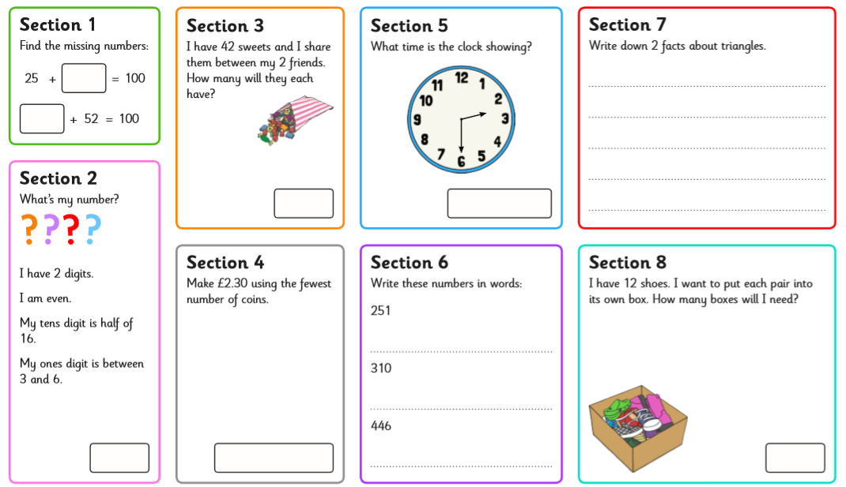
Parents - This could be used as an assessment and more focus could be given to areas that your child finds difficult.

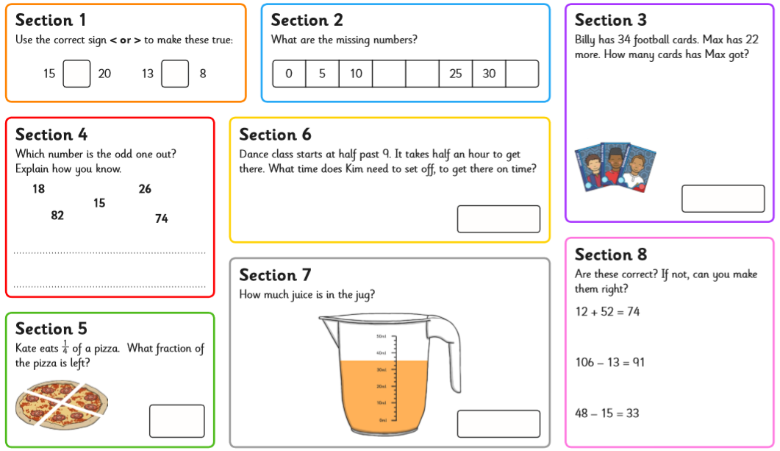
Maths Day 4 - Revision of previously taught areas.
Maths Day 5 - Revision of previously taught areas.
