Rocks and soil 22nd June 2020
Our lives depend on rocks and soils. We need them to grow our food, build our houses and to make many more important things. Even the planet we live on is mainly rocks and soils.
- Glass is made from special sand and limestone, heated together.
- Metals are found in rocks called ores.
- Plastics are made from oil, which is formed deep under the ground.
- Tiles are made from clay.
- Pottery is made from clay.
Look at the image of a kitchen, which things are made from rocks and ?soils?
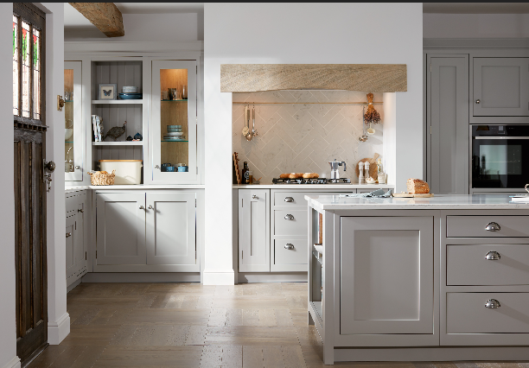

Challenge:
Now think about your bathroom at home.
How many things in there are made with rocks and soils?

