Date: _____________________________________________________________________
LO: To recall and use division facts for the 2 times table.

Varied Fluency

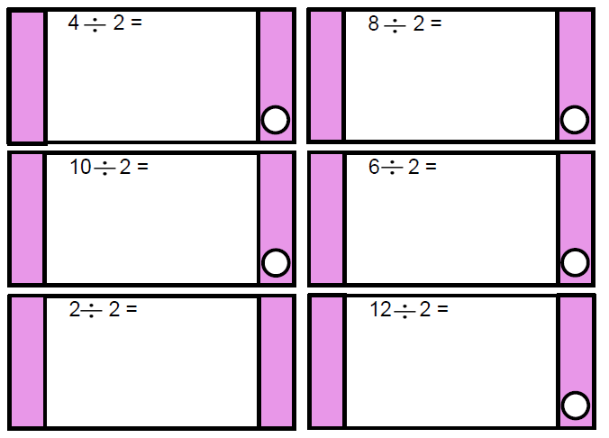

Reasoning and Problem Solving

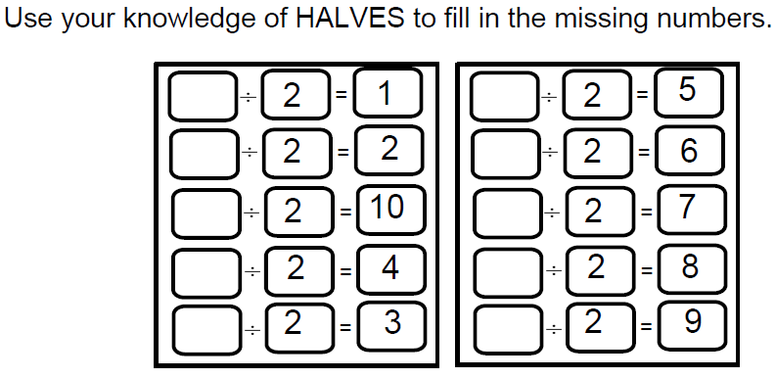

LO: To recall and use multiplication facts for the 5 times table.

Varied Fluency

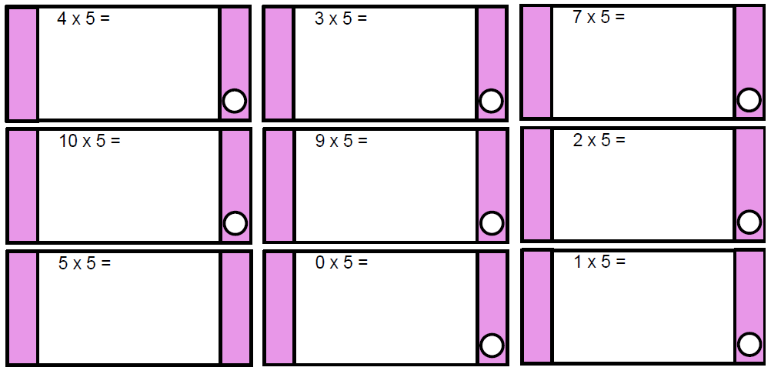

Reasoning and Problem Solving

