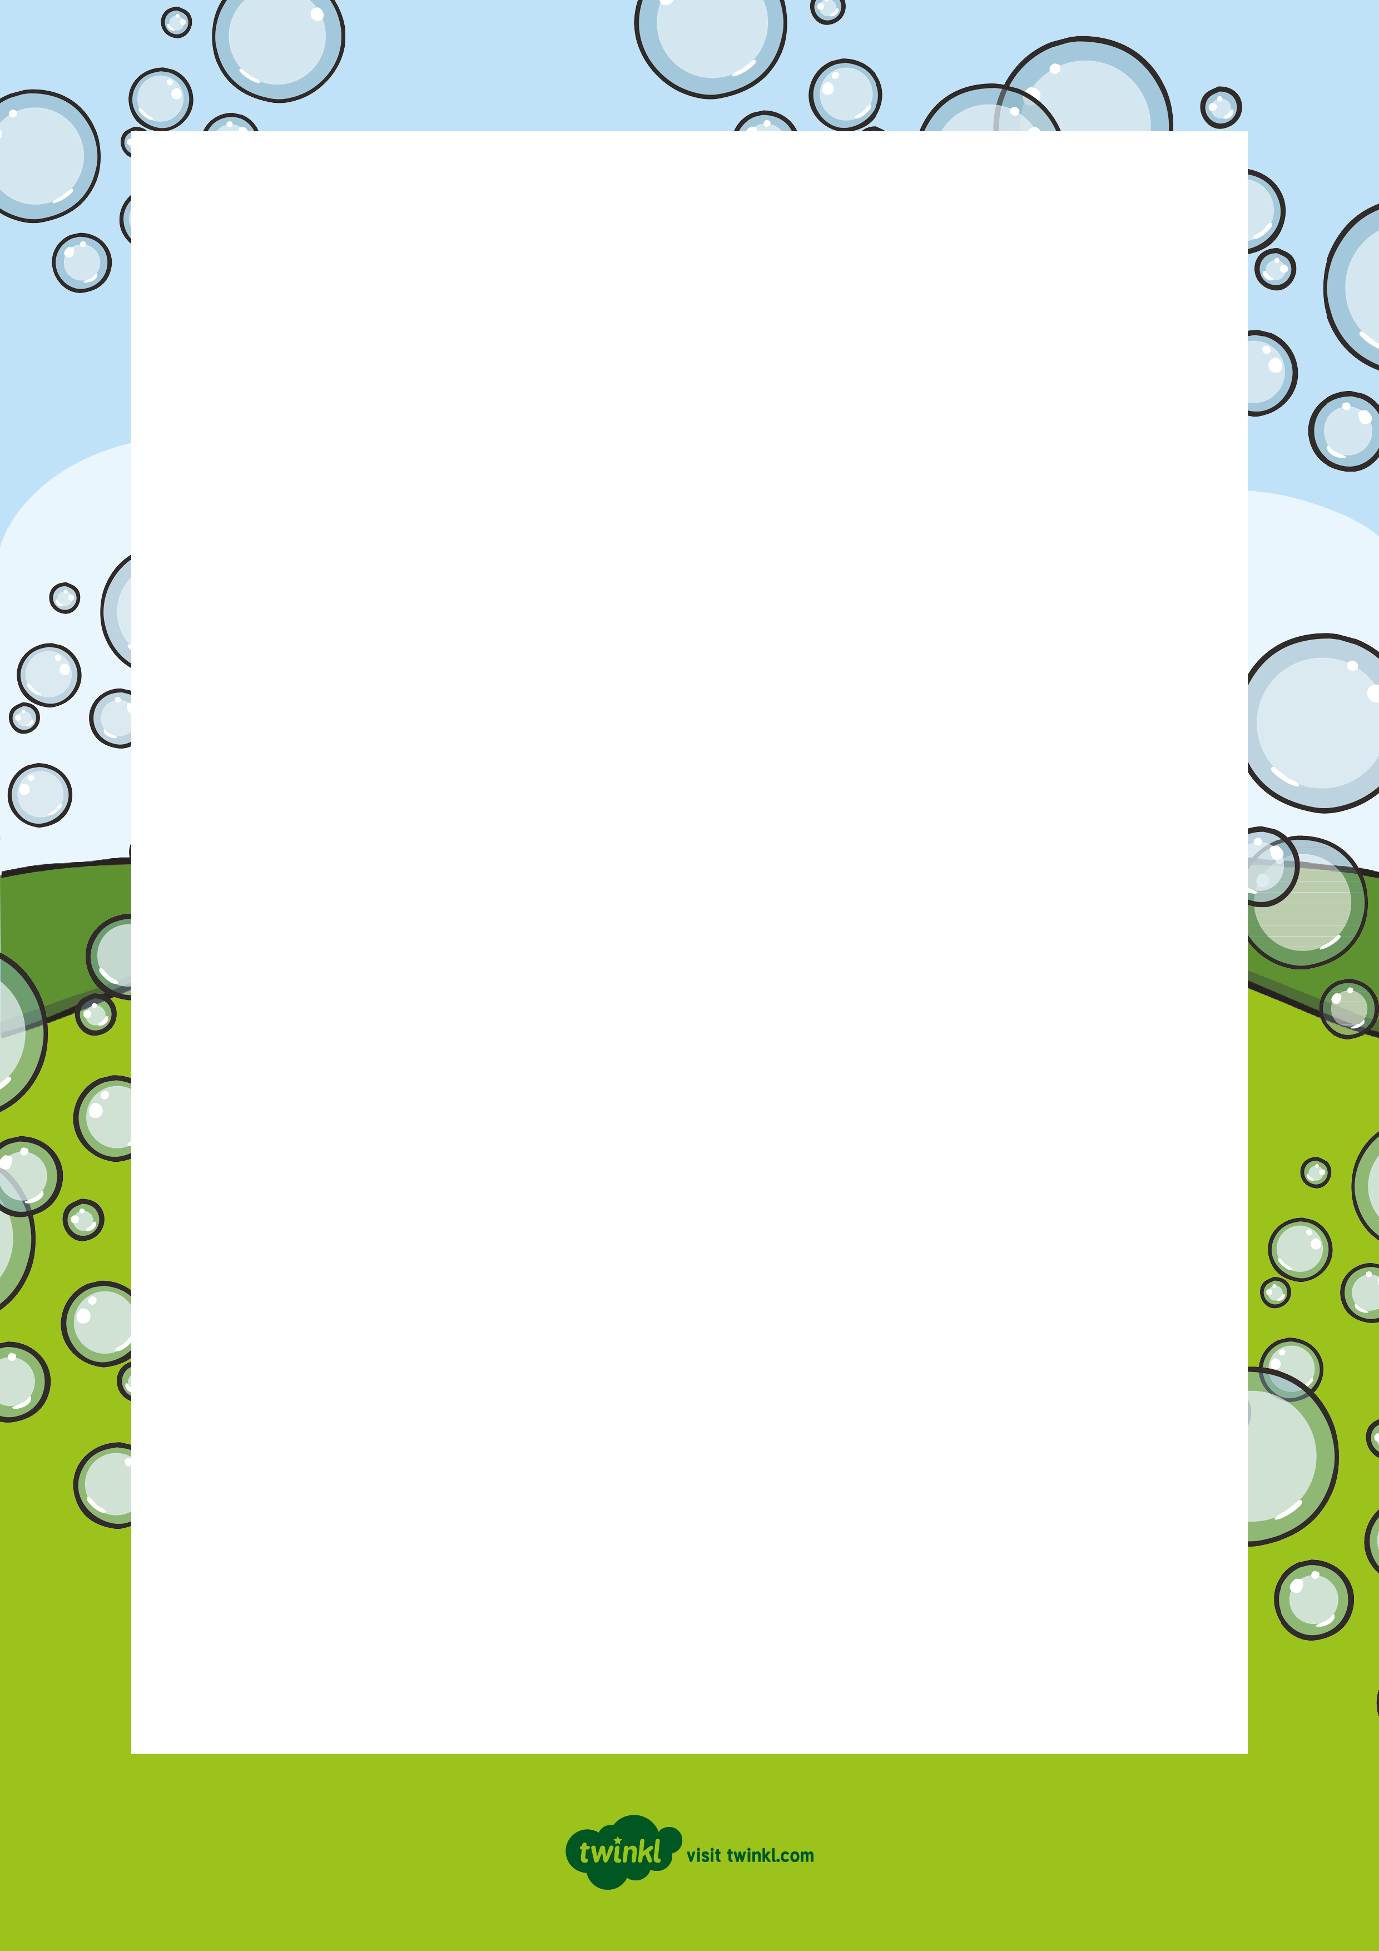
Hello children!
My name is Professor Bubble. I am a scientist, which means I like investigating and learning about how things work.
During the summer, one of my favourite things to do is to investigate bubbles! I have made a special recipe that is really good for blowing bubbles and I like to go outside and see how many bubbles I can make. Last week, I made a really big bubble – it was almost as big as an apple!
I know that you all like to explore and investigate new things so I have sent you the recipe for my special bubble mix!
You could explore blowing bubbles to see who can make the biggest bubble or who can blow the most bubbles! Can you catch the bubbles without popping them? Can you make the bubbles float high into the sky?
Maybe you could send me some photos or pictures of the bubbles you make!
I hope you have fun blowing lots and
lots of bubbles.
From
Professor Bubble



