Film review
Great news – this week it is mandatory for you to watch a film!

When you have finished watching it, please complete the following activities. As you watch, please keep in mind the setting (where the story takes place), the characters and what is happening in the story!

Remember to use the following things in all of your writing:
. Capital letters
. Full stops
. Neat joined up handwriting
. Sound out your words carefully
. Spell common exception words correctly
. Use conjunctions: and/but/or because/when/if/that
. Use the correct tense

Don’t forget to read and edit your writing to make sure it makes sense!

Day 1
Where is your film set?
* Draw a picture of your setting and label it with adjectives.
* Describe your setting in full sentences and use conjunctions.

________________________________________________________________

________________________________________________________________

________________________________________________________________

________________________________________________________________

________________________________________________________________

________________________________________________________________

________________________________________________________________

________________________________________________________________

________________________________________________________________

________________________________________________________________

________________________________________________________________

________________________________________________________________

Day 2
Who are the main characters in your story? Are they good or bad?
* Choose two characters to draw and describe.
* Describe your characters in full sentences and use conjunctions.
* Remember to describe their appearance and their personality

________________________________________________________________
________________________________________________________________
________________________________________________________________
________________________________________________________________
________________________________________________________________
________________________________________________________________
________________________________________________________________

________________________________________________________________
________________________________________________________________
________________________________________________________________
________________________________________________________________
________________________________________________________________

Day 3
What happens in the story? Draw a story map – include as much detail as you can!
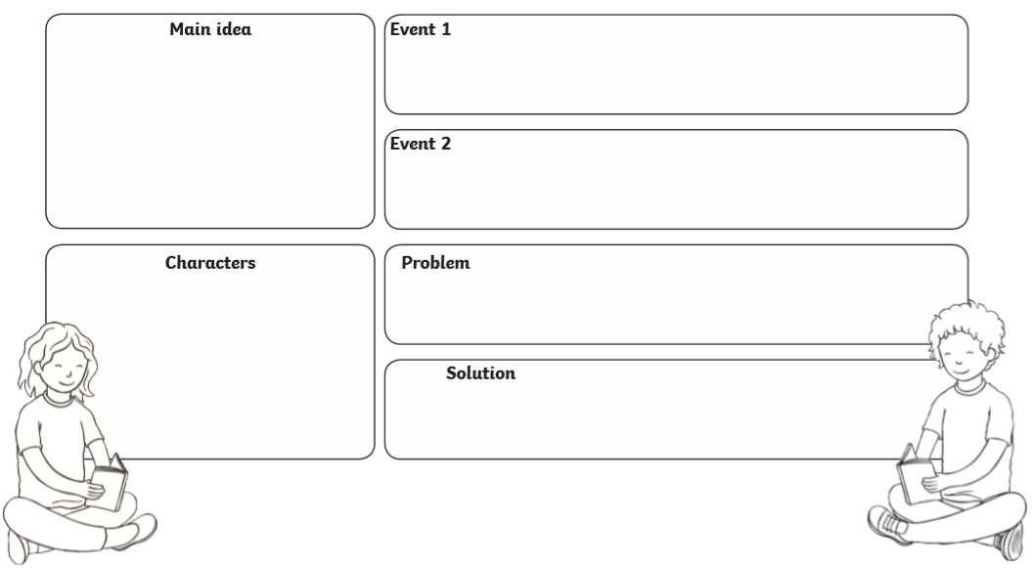

Day 4 – Review your film. Would you recommend others to watch it?
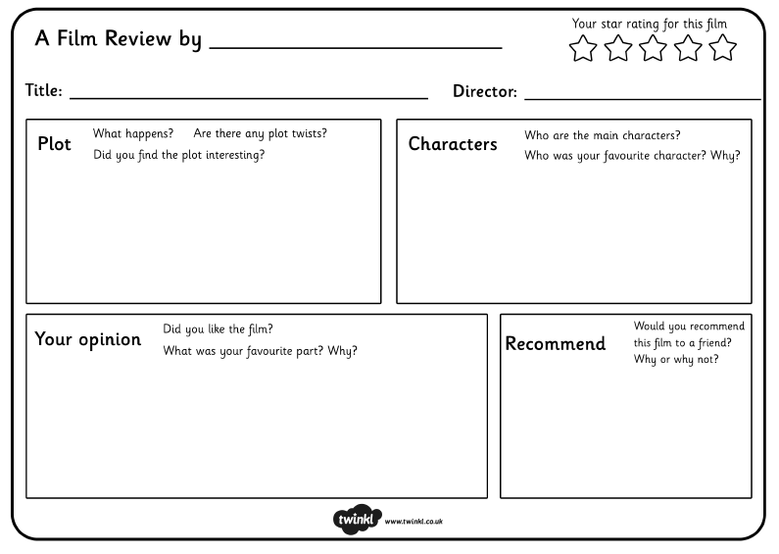
Day 5 - Forms of speech
- Can you write sentences these characters might be saying in the speech bubbles?
- Then write them on the lines using inverted commas.

- An example has been done for you:

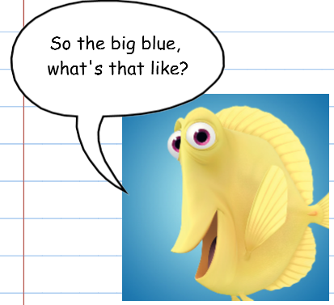
“So the big blue, what’s that like?” asked Bubbles.

Or

Bubbles said “So the big blue, what’s that like?”

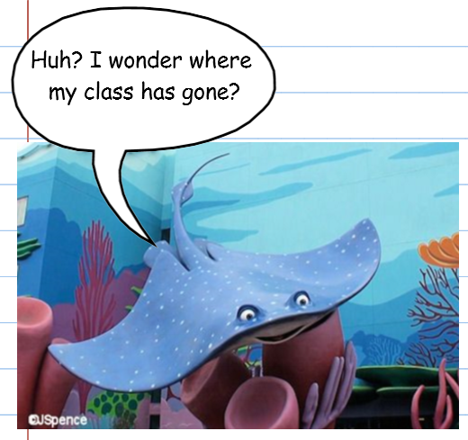
Mr Ray

________________________________________________________________
________________________________________________________________
________________________________________________________________

Dory:
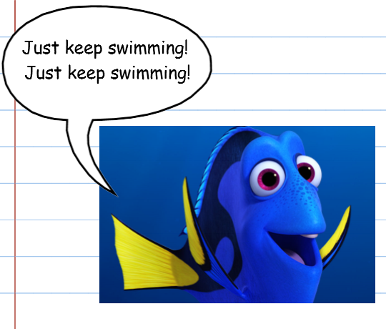

_______________________________________________________________

_______________________________________________________________

_______________________________________________________________

Sheldon the seahorse:






