WB 11th May
Spelling homework: copy each word five times. Challenge: write one sentence using one of the words
Spelling rule: less, ment, ful & ness suffixes
Day 1 | Day 2 | Day 3 | Day 4 | Day 5
endless | government | successful | awareness | joyless
useless | development | useful | weakness | joyful
homeless | management | helpful | darkness | peacefulness
hopeless | movement | wonderful | sickness | carelessness
helpless | department | powerful | fitness | shyness

Use your green exercise books to complete this work.
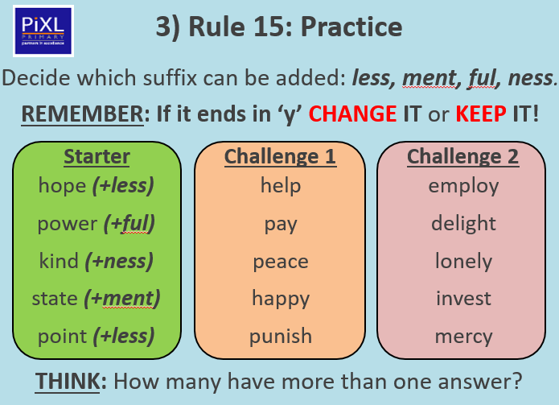
Ask someone at home to read out the dictation for you to write without looking at it.
