Date:________________________________________________________

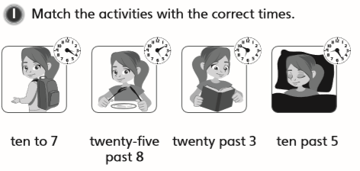LO: To tell the time to 5 minute intervals

Practice

