This is the story of Roger Rock - Soil formation 06.7.2020
Roger Rock was hard. People broke hammers and spades on his hard, rocky shape. He was proud of being unbreakable. However, strange things were happening to him. He seemed to be getting smaller!
However, strange things were happening to him. He seemed to be getting smaller! In the middle of winter, his cracks filled with water. The water froze, and the ice began to push at him. Then… CRACK! The ice made him split and more pieces were falling off!
Then there was the river that swept past him. That river would rub little rocks against him, over and over again. When the rocks rubbed him little pieces wore off. Then, when the river swept big rocks past him, they would smash off other pieces from him and carry them away!
One day, Roger looked at himself and noticed he looked very different from before. He realised now that he had the wrong name!
'I'm Simon Soil' he said.

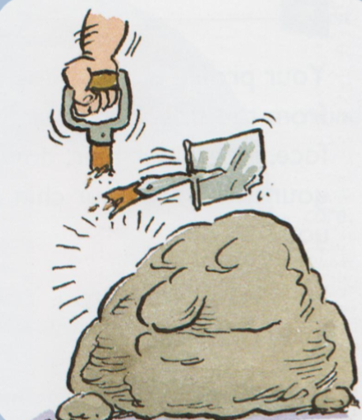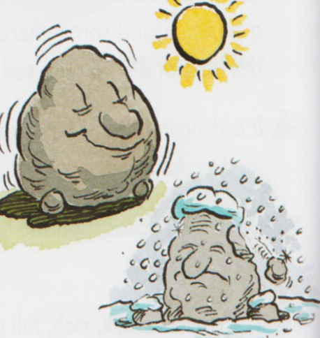
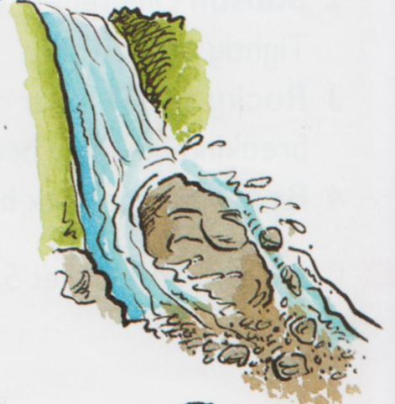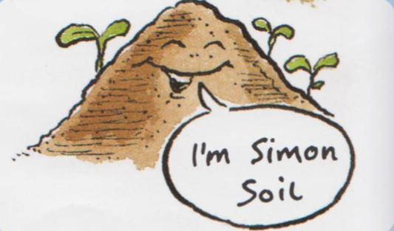

LO: understanding the formation of soil from rocks 29.6.2020
Your task
Create a story board explaining the different stages of how soil is formed

