This week we would like you to do some writing based on summer. There will be lots of different writing for you to show off what you have learnt this year.

Remember to use all of the following things in all of your writing:
- Capital letters
- Full stops
- Neat joined up handwriting
- Sound out your words carefully
- Spell common exception words correctly
- Use conjunctions:
and/but/or
because/when/if
- Use the correct tense
Read over your writing to make sure it makes sense

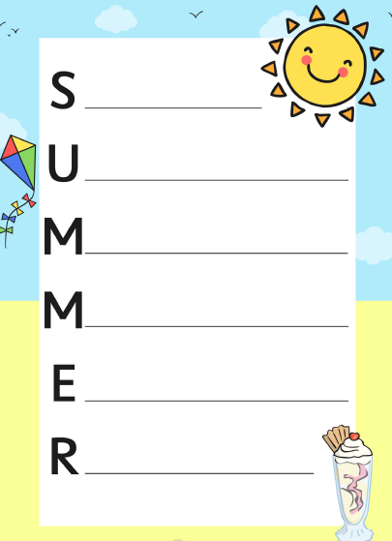
Day 1
LO: To write an acrostic poem about summer.

Day 3
LO: To write a description for a fictional island.
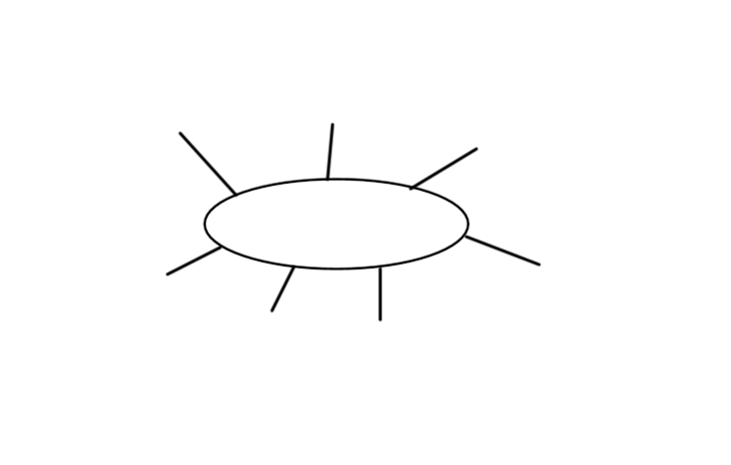
________________________________________________________________________________________________________________________________________________________________________________________________________________________________________________________________________________________________________________________________________________________________________________________________________________________________________________________________________________________________________________________________________________________________________________________________________________________________________________________________________________________________________________________________________________________________________________________________________________________________________________________________________________________________________________________________________________________________________________________________________________________________________________________________________________________________________________________________________________________________________________________________________________________________________________________________________________________________________________________________________________________________________________________________________________________________________________________________________________

Day 3
LO: To create a poster for your fictional island.
Think about the information you would need to put on a poster to make someone want to visit your island. Remember to use eye-catching pictures and information!

Day 4
LO: To write a post card.
Imagine you have visited the island which you created this week. You are going to write a postcard to someone and tell them about the time you have had on your island. Remember to write in the first person – I, me, we, us.

_____________________________________________Address:_______________________________________________________________________________________________________________________________________________________________________________________________________________________________________________________________________________________________________________________________________________________________________________________________________________________________________________________________________________________________________________________________________________________________________________________________________________________________________________________________________________________________________________________________________________________________________________________________________________________________________________________________________________________________________________________________________________________________________________

