Date: __________________________________
LO: To use estimation to check your answers to calculation are reasonable

Guess what 24 + 32 = ______
Prove it by adding together the tens and then the ones __________________________________
__________________________________

Guess what 15 + 15 + 15 = _______
Prove it by adding together the tens and then the ones __________________________________
__________________________________

Guess what 75 + 15 = ______
Prove it by adding together the tens and then the ones __________________________________
__________________________________

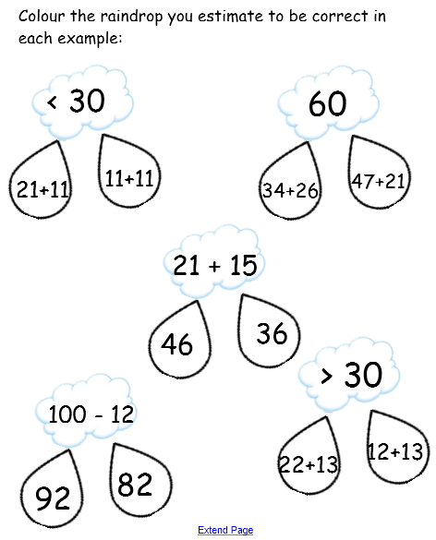
Challenge

