Date:___________________

LO: To show equal amount of money

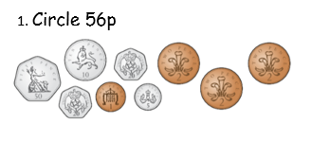

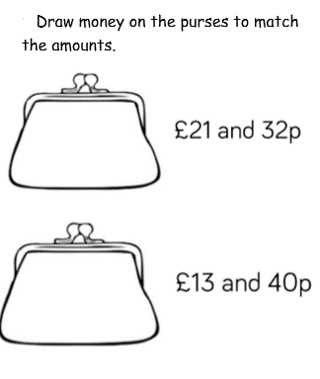

How much money is below? ____________

  

How much money is below? _____________



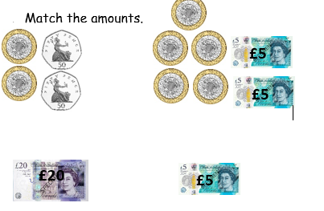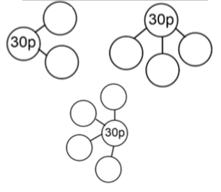Complete the part-whole models.

Challenge:

