WB 6th July
YOU MUST DO:

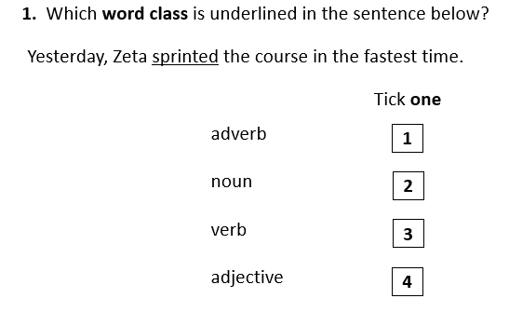
YOU SHOULD DO:

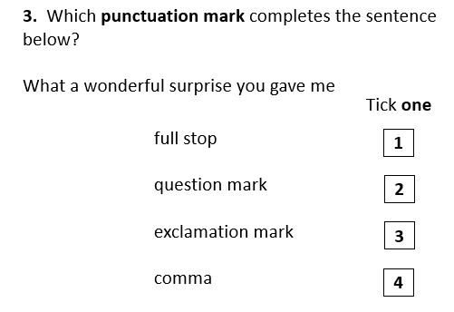
YOU COULD TRY:

