WB 15th June
YOU MUST DO:

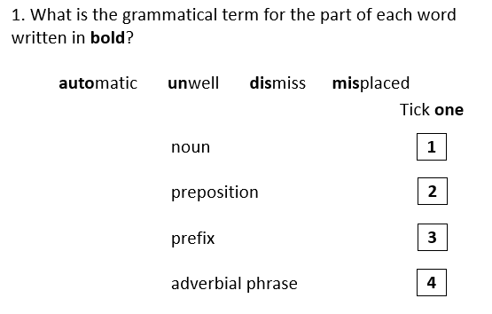
YOU SHOULD DO:

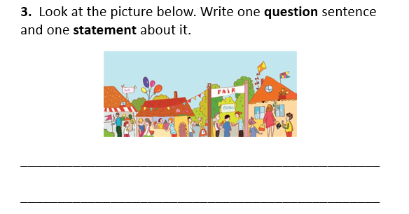
YOU COULD TRY:
