LO: to understand the different ways plants disperse their seeds. Activity 7
Read the notes to help you complete the task ahead.
Last week we looked at the life cycle of a flowering plant. The last stage in the cycle was seed dispersal (how seeds are moved about). This week, we are going to look at the fascinating ways that plants have created to move their seeds so they can grow in different places.
Wind  Sycamore ‘helicopters’ and dandelion ‘clocks’ both have fruits which have adapted to use the wind to carry the seeds away when the seeds are ready. | 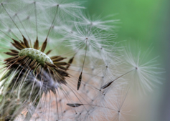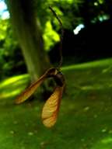
Bursting  Some plants have pods full of seeds which will burst showering the ground with seeds. Peas are examples of bursting open to disperse its seeds. | 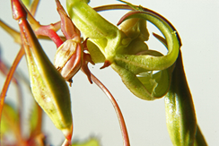
Shakers  Some plants rely on being shaken to disperse their seeds. When poppies have produced their seeds and have finished flowering all that is left is a long stem with a dried seed pod. These pods have small holes at the top and rely on wind to shake them to scatter the seeds. | 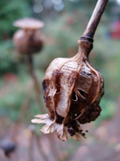
Water  Some plants rely on water to disperse their fruits. These will either grow on the water or by the side of water. Water lilies live on the water so they use the water to disperse their seeds. | 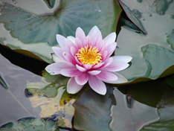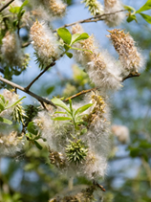
Catching a ride  Some plants such as cockleburs have developed to grow tiny hooks on their fruits which hook on to animals (or people) that pass by the plant. Eventually they will drop off on to the ground. | 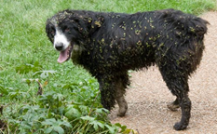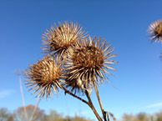
Seeds as food  Some plants make tasty fruits. This is to encourage animals (and people!) to eat the fruits | 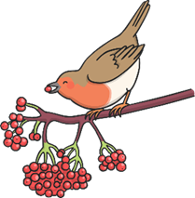
Drop and roll  Some fruits, such as horse chestnuts, have a casing round them which cracks open when it hits the ground. The fruit inside then rolls away from the tree. | 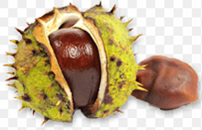

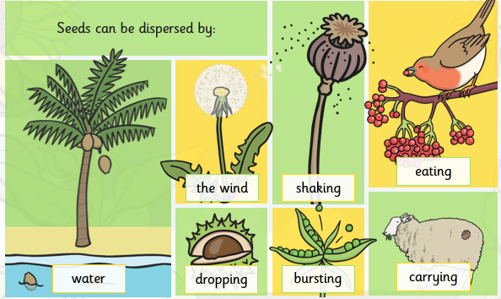

Your Task
Cut out the selection of fruits and seeds and sort them into the way they are dispersed.
Create a table
Stick each picture in the right column
Wind | Bursting | Water | Shaker | Catch a ride | Seed as food | Drop and roll

