Non-fiction Writing: Owls
This week we would like you to write some more non-fiction pieces of writing. Your writing will be based on our second nocturnal animal: Owls. You will need to research and write about all aspects of an owl. We look forward to seeing some of your work.

Remember to use the following things in all of your writing:
. Capital letters
. Full stops
. Neat joined up handwriting
. Sound out your words carefully
. Spell common exception words correctly
. Use conjunctions: and/but/or because/when/if
. Use the correct tense

Don’t forget to read and edit your writing to make sure it makes sense!

Day 1: Today we would like you to write all about what you already know about owls. Have a discussion with your family to see if they can add in any facts.
Just for fun, you can watch this fictional story about an owl. Remember, if the link doesn’t work you can always search ‘The Owl who was afraid of the dark’ on YouTube.
https://www.youtube.com/watch?v=y1iST5Bdir8
___________________________________________________________________________
___________________________________________________________________________
___________________________________________________________________________
___________________________________________________________________________
___________________________________________________________________________
___________________________________________________________________________
___________________________________________________________________________
___________________________________________________________________________
___________________________________________________________________________
___________________________________________________________________________
___________________________________________________________________________
___________________________________________________________________________
___________________________________________________________________________
___________________________________________________________________________
___________________________________________________________________________
Are there any questions that you would like to find answers about this week when you research owls?
___________________________________________________________________________
___________________________________________________________________________
___________________________________________________________________________
___________________________________________________________________________
___________________________________________________________________________
___________________________________________________________________________
___________________________________________________________________________
___________________________________________________________________________

Day 2: Today we would like you to research and write about habitat of different owls. Lots of information can be found at the following website
https://www.rspb.org.uk/birds-and-wildlife/wildlife-guides/bird-a-z/
Draw an owl habitat in the box below and then write any habitat facts you have found out about different species of owl.
___________________________________________________________________________
___________________________________________________________________________
___________________________________________________________________________
___________________________________________________________________________
___________________________________________________________________________
___________________________________________________________________________
___________________________________________________________________________
___________________________________________________________________________
___________________________________________________________________________
___________________________________________________________________________
___________________________________________________________________________

Day 3: Today we would like you to research and write about diet. What does an owl eat? Are there any interesting facts you can find out about what owls do with bits they cannot digest?
Design a poster showing an owl catching its prey and where they might find different prey.

Interesting facts:
___________________________________________________________________________
___________________________________________________________________________
___________________________________________________________________________
___________________________________________________________________________
___________________________________________________________________________
Day 4: Today we would like you to read and write about different types of owls. Read the information below and choose your favourite fox. Now create a fact file about your chosen type of owl. Remember to include lots of information and pictures, you could add extra facts as well!
The Little Owl is our smallest species. They nest in old buildings, tree hollows, sometimes in holes in the ground and in nest boxes. They can often be seen during the day on tops of farm buildings and telegraph poles.

The Barn Owl nests in farm buildings, tree hollows, haystacks and nest boxes.

The elusive Long-eared Owl is an elusive owl, smaller than a Barn Owl, and one that normally breeds in conifer forests and large areas of scrub, using the abandoned nests of crows or similar.

The Short-eared Owl is a ‘cousin’ of the Long-eared owl, but is a diurnal (daytime) species. This ground nesting owl breeds in northern Britain.

The Tawny Owl is our familiar hooting owl. Tawny owls stay in their woodland home all year round, nesting in tree hollows, old crow’s nests or nesting boxes. They fiercely defend their territory and also their young, which leave the nest at a very young age.

Remember to use the internet to research more about each type of owl. This website will help you again.
https://www.rspb.org.uk/birds-and-wildlife/wildlife-guides/bird-a-z/

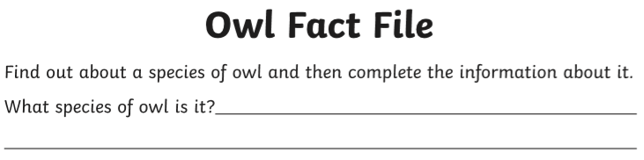
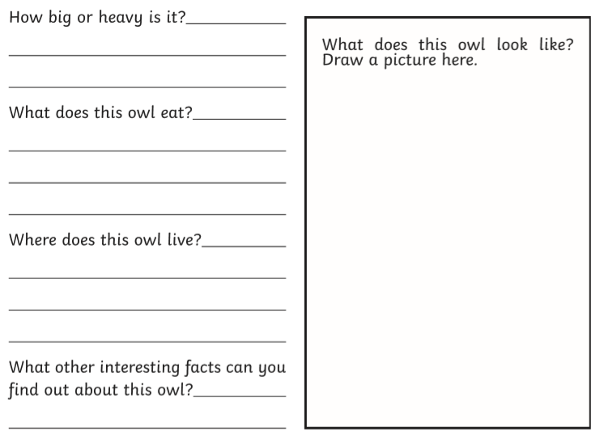

Day 5: Finally, create a poster about all the different features of an owl. The information below will help but make sure to research and ask questions where you can.
