WB 8th June
YOU MUST DO:

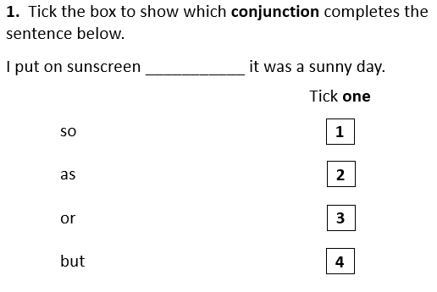

YOU SHOULD DO:

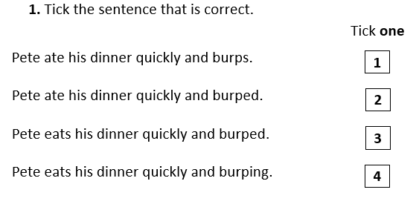
YOU COULD TRY:

