Day 3 - LO: To recap fractions.
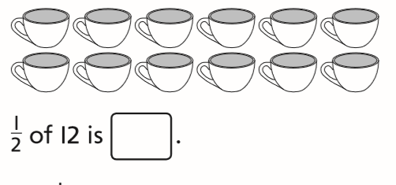
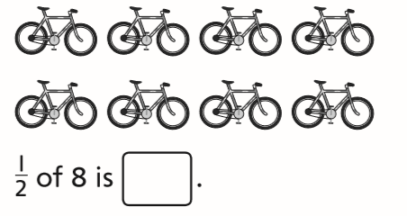

Shade 1/2 of each shape. Complete the number sentence.
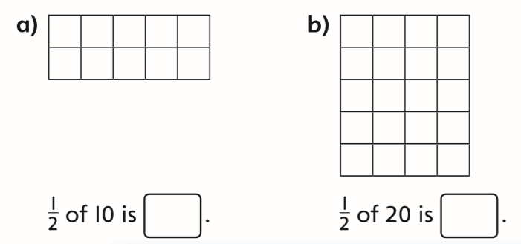

Share the counters equally into four groups.
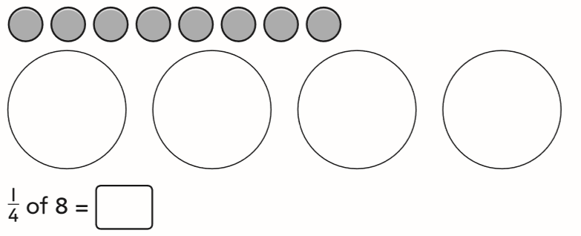

Sita has 20 ﬂowers. She shares them between four vases equally. How many ﬂowers are in each vase?
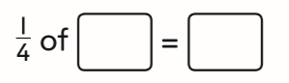
Challenge:
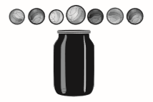
Cassie has some marbles.
Here are half of them.
The rest are in the jar.
How many marbles does Cassie have in total?
Cassie has ___________ marbles in total.

Half of a number is 6.
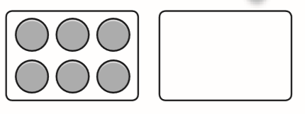
The whole number is _________
¼ of the number is __________

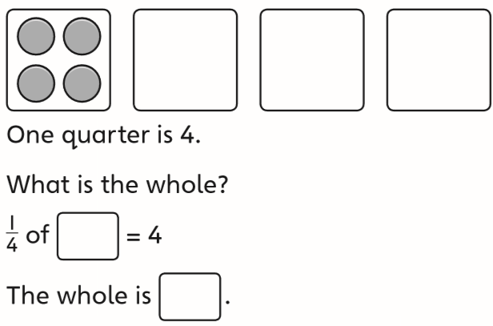

Challenge:
