Date: ________________ LO: To identify and record the properties of 3D shapes

Varied Fluency
3D Shape | Name | Number of Faces | Number of Edges | Number of Vertices
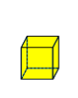
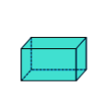
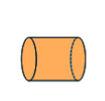
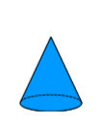

Problem solving:

- What is the same about a cube and cuboid?
_________________________________________________________________
_________________________________________________________________
- What is different about a cube and cuboid?
_________________________________________________________________
_________________________________________________________________
- Which 3D shapes have curved faces?
_________________________________________________________________
_________________________________________________________________
- What 2D shapes are the faces on a square-based pyramid?
_________________________________________________________________
_________________________________________________________________

Jottings
